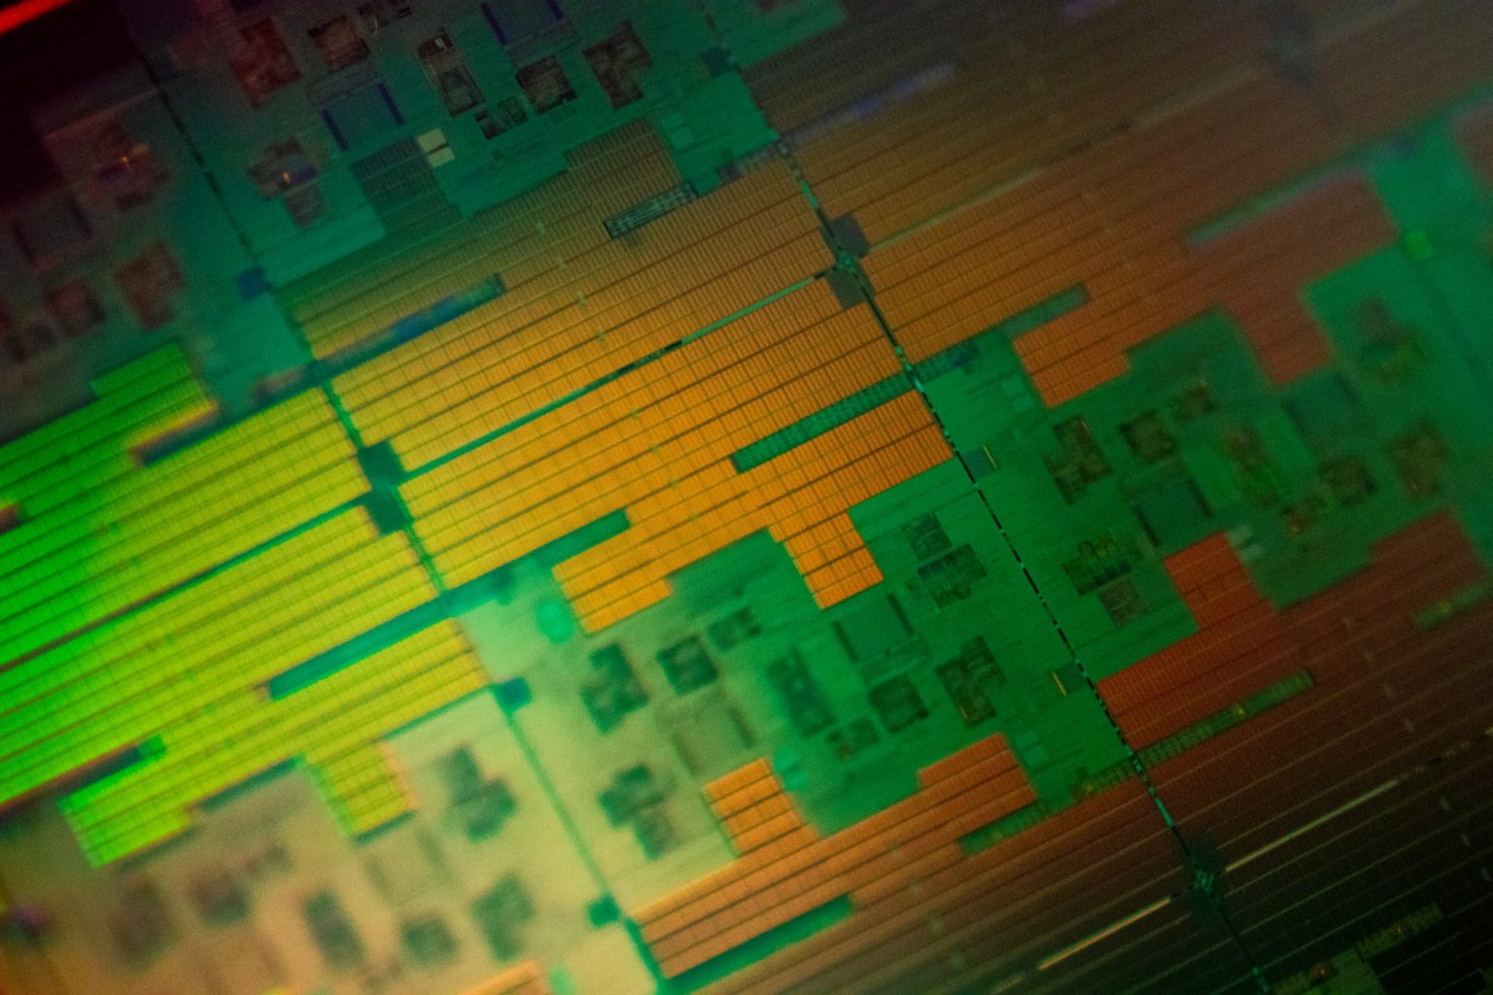
Semiconductor theory document
LO3
Akbar Qamar | [Date] | 4019

Contents
1. Introduction (≈ 100–150 words) 3
2. Semiconductor fundamentals (intrinsic vs extrinsic) (≈ 200–300 words) 4
2.1 Intrinsic semiconductors 4
2.2 Extrinsic semiconductors (doping) 4
3. The p–n junction and diode behaviour (≈ 300–450 words) 5
3.1 Formation of a p–n junction 5
3.2 Forward bias vs reverse bias 5
4. Zener diode and regulation concept (≈ 200–300 words) 7
4.1 Zener breakdown and reverse operation 7
5. LED operation (≈ 150–250 words) 8
6. BJT basics (npn & pnp) — junction behaviour, switch + amplifier (≈ 350–500 words) 9
6.1 What a BJT is (junction-level view) 9
6.3 BJT as an amplifier (basic) 9
7. JFET and MOSFET basics (≈ 300–450 words) 11
7.1 JFET (basic operation) 11
7.2 MOSFET (basic operation) 11
8. Device comparison and typical applications (≈ 250–350 words) 13
10. Conclusion (≈ 100–150 words) 14
Bibliography 15

No table of figures entries found.

1. Introduction (≈ 100–150 words)
What to write
State the aim: explain semiconductor physics and how it leads to device behaviours and applications.
List the devices covered: diode (incl. Zener), LED, BJT, JFET, MOSFET.
Mention that practical testing is evidenced in the lab workbook, while this document focuses on theory and datasheet-based performance.
Prompt
[Insert: brief block diagram or “device family map” showing diode/LED/BJT/JFET/MOSFET and typical uses]

2. Semiconductor fundamentals (intrinsic vs extrinsic) (≈ 200–300 words)

2.1 Intrinsic semiconductors
Include
- crystal lattice concept (Si/Ge)
- charge carriers: electrons and holes
- temperature dependence (qualitative)
Image/diagram prompt
- Figure 1: [Insert labelled diagram: silicon lattice (covalent bonds) + thermal generation of electron-hole pairs]
Caption: “Intrinsic semiconductor carrier generation.”

2.2 Extrinsic semiconductors (doping)
Include
- dopants: donor (Group V) → n-type, acceptor (Group III) → p-type
- majority/minority carriers
- why doping changes conductivity
Image/diagram prompt
- Figure 2: [Insert labelled diagram: doped lattice showing donor/acceptor + free carrier]
prompts
Define intrinsic/extrinsic; state what changes with doping.
Explain (briefly) how majority/minority carriers impact device behaviour later.
Link performance idea: “higher doping → narrower depletion region → affects forward voltage / breakdown tendency (qualitative).”
Research hints (use 1–2 sources, not many)
- Textbooks: Bolton (Mechatronics), Alciatore & Histand (Measurement Systems), introductory electronics texts.
- Keywords: “intrinsic vs extrinsic silicon”, “donor acceptor doping majority carriers”.

3. The p–n junction and diode behaviour (≈ 300–450 words)

3.1 Formation of a p–n junction
Include
- diffusion of carriers → depletion region
- built-in potential barrier (qualitative)
- equilibrium condition
Diagram prompt
- Figure 3: [Insert labelled diagram: p–n junction showing depletion region + ionised donor/acceptor ions]
- Optional Figure 4: [Insert energy band diagram (simple) showing barrier]

3.2 Forward bias vs reverse bias
Include
- forward bias reduces barrier → current increases rapidly
- reverse bias increases barrier → small leakage until breakdown
- mention temperature effect (qualitative): forward voltage decreases with temperature for silicon (brief)
Graph prompt
- Figure 5: [Insert diode I–V curve: forward region exponential-like; reverse leakage; breakdown region]
Add labels: Vf, Is/leakage, Vbr.
prompts
- Describe forward and reverse bias behaviour using semiconductor terms (depletion region/barrier/carriers).
- Use simple theory to explain why current rises strongly in forward bias (barrier reduction → carrier injection).
- Discuss performance links: forward drop (Si ~0.7 V typical), reverse rating, leakage, temperature sensitivity and why it matters in rectifiers/regulators.
Quick application note (1 short paragraph)
- rectification: converting AC to DC (half-wave/full-wave concept)
- why diode ratings matter (IF, VRRM, power)
Diagram prompt
- Figure 6: [Insert simple rectifier diagram: half-wave or bridge]
[Optional: insert expected output waveform diagram]

4. Zener diode and regulation concept (≈ 200–300 words)

4.1 Zener breakdown and reverse operation
Include

Zener diode designed to operate in reverse breakdown
regulation concept: holds approx constant voltage across load (within limits)
mention dynamic resistance (qualitative) and current limits
Circuit diagram prompt

Figure 7: [Insert Zener regulator circuit: Vin → series resistor → Zener to ground + load]
Annotate: Vin, Rs, Iz, IL, Vout ≈ Vz.
Graph prompt

Figure 8: [Insert Zener I–V curve highlighting breakdown knee and regulation region]
prompts

Describe reverse-bias breakdown behaviour and its use.
Analyse how series resistor limits current and enables regulation (cause-effect explanation).
Discuss performance: regulation quality vs load change, power dissipation limits, tolerance, temperature coefficient (brief, datasheet-supported if possible).

5. LED operation (≈ 150–250 words)
Include
- LED as a p–n junction emitting photons (electroluminescence)
- forward voltage depends on material/bandgap → colour
- need for current limiting resistor/driver (concept)
Diagram prompts
- Figure 9: [Insert LED symbol + simple current-limiting circuit]
- Optional Figure 10: [Insert simple spectrum/colour vs wavelength chart or LED I–V curve]
prompts
- Describe LED forward bias operation as a p–n junction device.
- Explain how bandgap relates to emitted light (simple statement is enough).
- Discuss performance: luminous intensity vs current, efficiency, thermal management, viewing angle, maximum ratings.

6. BJT basics (npn & pnp) — junction behaviour, switch + amplifier (≈ 350–500 words)

6.1 What a BJT is (junction-level view)
Include
- npn/pnp structure (two p–n junctions)
- base-emitter junction forward biased for conduction
- collector current controlled by base current (concept)
- define regions: cutoff, active, saturation (simple)
Diagram prompts
- Figure 11: [Insert npn and pnp symbols + labelled terminals]
- Figure 12: [Insert simple internal structure or equivalent diode model]
6.2 BJT as a switch
Include
- cutoff (OFF), saturation (ON)
- why base resistor is needed
- typical use: driving relay/LED/motor driver stage (concept only)
Diagram prompt
- Figure 13: [Insert BJT low-side switch circuit with base resistor and load]

6.3 BJT as an amplifier (basic)
Include
- active region idea: small base signal controls larger collector current
- mention biasing is needed (do not over-detail)
- small-signal concept can be brief (gain β/hFE)
Graph prompt
- Figure 14: [Insert output characteristics Ic vs Vce for different Ib OR simple transfer concept]
P/M/D prompts
- P (must): Describe pnp/npn junction behaviour using semiconductor language (junction biasing, carrier flow).
- M: Analyse operation in switch vs amplifier mode (regions and why they differ).
- D: Discuss performance: gain variation (β spread), saturation voltage VCE(sat), switching speed, thermal effects, safe operating area (SOA) — link to applications.

7. JFET and MOSFET basics (≈ 300–450 words)

7.1 JFET (basic operation)
Include

voltage-controlled device; gate-channel junction reverse biased
pinch-off concept (qualitative)
define Idss, Vp (brief)
Diagram/graph prompts

Figure 15: [Insert JFET symbol + simple channel diagram]
Figure 16: [Insert JFET transfer curve Id vs Vgs (typical shape)]

7.2 MOSFET (basic operation)
Include

insulated gate (high input impedance)
enhancement-mode n-channel and p-channel (mention both)
Vth (threshold) concept
RDS(on) relevance for switching losses (basic)
Diagram/graph prompts

Figure 17: [Insert MOSFET symbol(s) + labelled terminals]
Figure 18: [Insert MOSFET transfer characteristic Id vs Vgs OR RDS(on) vs Vgs plot (datasheet-based if possible)]
prompts

Describe how FET control differs from BJT (voltage vs current control).
Analyse device operation using simple semiconductor theory (junction control in JFET; electric field/inversion channel concept for MOSFET—keep simple).
Discuss performance in applications: gate drive needs, switching speed, conduction losses (RDS(on)), thermal limits, body diode in MOSFETs.

8. Device comparison and typical applications (≈ 250–350 words)
Create a short comparison that links theory → behaviour → where it’s used.

Suggested table prompt

Table 1: [Insert comparison table: Diode vs Zener vs LED vs BJT vs JFET vs MOSFET]
Columns you can use:
Control method (current/voltage)
Key behaviour (junction/breakdown/field effect)
Typical application
Key performance constraints (ratings, losses, speed)
Application prompts (pick at least 4)

Rectification (diode bridge)
Voltage reference/regulation (Zener regulator)
Switching a load (BJT or MOSFET switch)
Amplification (BJT common-emitter idea)
Signal switching/analogue control (JFET/MOSFET)
prompt

Include at least one paragraph discussing performance trade-offs (e.g., “MOSFET lower conduction losses vs BJT base drive”, “Zener regulation limited by power/tolerance”, etc.).

10. Conclusion (≈ 100–150 words)
Summarise:

how semiconductor physics explains p–n junction behaviour
how that theory extends to diodes/LEDs/BJTs/FETs
key performance trade-offs and application suitability

Bibliography
There are no sources in the current document.

